Name: L.Ishitha
Roll Number: 2420030041
Sec-5

OSPF Routing Commands

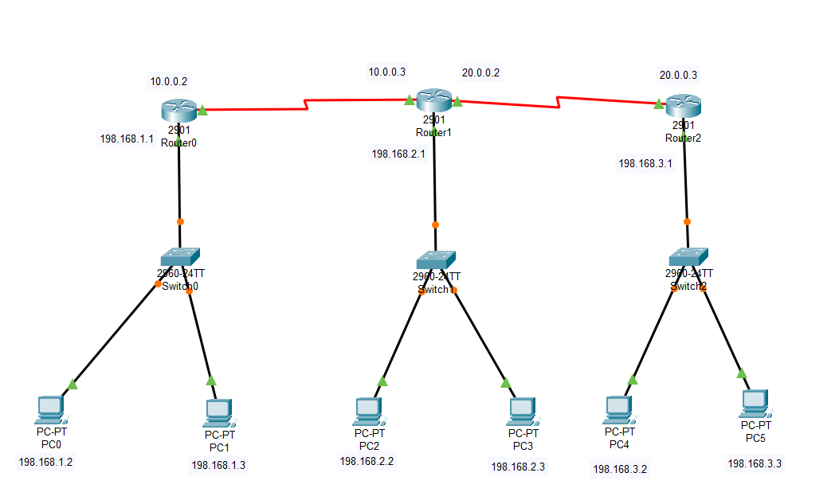
1. Enter Global Configuration Mode
Command: configure terminal
This command is used to enter the global configuration mode on a Cisco router.

2. Enable OSPF Routing Process
Command: router ospf <process-id>
This enables the OSPF routing process on the router.
Example: router ospf 1

3. Configure OSPF Network Statements
Command: network <network-address> <wildcard-mask> area <area-id>
This command specifies which interfaces participate in OSPF and assigns them to an area.
Example: network 192.168.1.0 0.0.0.255 area 0

4. Verify OSPF Configuration
Command: show ip ospf neighbor
This shows OSPF neighbors and adjacency formation.
Command: show ip ospf interface
This shows OSPF-enabled interfaces.
Command: show ip route ospf
This displays OSPF-learned routes in the routing table.

5. Save Configuration
Command: write memory or copy running-config startup-config
This saves the OSPF configuration so that it persists after a reboot.

